­­­

November 2023  
**Blackboard Installation Guide**

**\*Note: You’ll need to install each App/Product separately, changing the name and custom parameters for installation.**

From within the *Courses* tab select the course where you’d like to add the Gale resource.

Select *Content* from the left navigation, then *Build Content*, then *Web Link.*

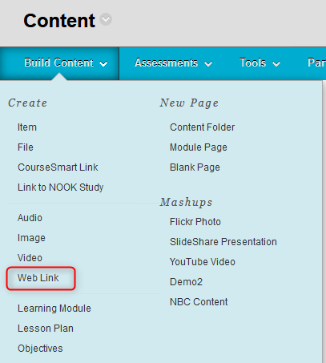

Fill in the information for creating a new Web Link, clicking the box next to “This Link is to a Tool Provider”

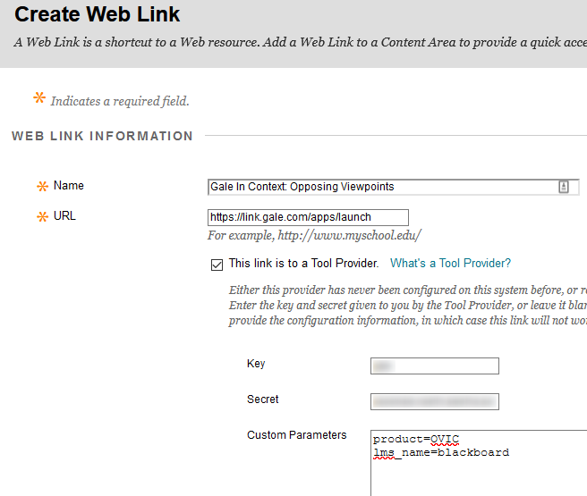

Name: Gale resource name

URL: launch URL **https://link.gale.com/apps/launch**

Key = Contact your [Gale Customer Success Manager](mailto:gale.customersuccess@cengage.com) if you don't know yours

Secret = Contact your [Gale Customer Success Manager](mailto:gale.customersuccess@cengage.com) to generate for you

Custom Parameters: Parameters vary by product and are available at <http://support.gale.com/technical/lms>

Example:

product=OVIC  
lms_name=blackboard

You have the option to add a Description and determine whether the resource opens in a new browser window or within the Blackboard frame (Open in New Window).

Click *Submit*

The resource now appears under *Content* in the course.

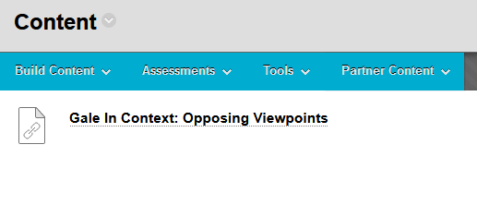

**\*Note: You may receive the error message below. There are two possible fixes when this error message is displayed.**“The tool provider is not supported. Only standard URL links to this site are permitted.”

**Fix 1:** The school or district administrator must enable Global Properties for LTI Providers in Blackboard and allow per link LTI configuration. After this step has been completed, the instructions above will allow installation by Web Link.

Within Blackboard administrator tools:

**Fix 2:** The school or district administrator must register Gale as an LTI Provider in the Blackboard admin interface.  
Any Gale URL is then recognised as being backed by the LTI provider key/secret, without any need to re-enter key/secret.

**Blackboard help links:**  
<https://help.blackboard.com/Learn/Administrator/SaaS/Integrations/Learning_Tools_Interoperability>  
  
<https://help.blackboard.com/Learn/Administrator/Hosting/System_Integration/LTI>